Object-Oriented Programming in Java
MISM/MSIT 95-712
Homework 5

- (60 points) The oldest known book on arithmetic is the Ahmes Papyrus, written by an Egyptian scribe 35 centuries ago. Fractions were apparently known at that time as well. A more ambitious problem involves unknown quantities, or variables. This idea is hinted in the old problem: “Hau, its whole, its seventh, it makes nineteen.” Hmmm, sounds like the equation x + x/7 = 19. By the Middle Ages (maybe 1200 A.D.?) the Arabic mathematician al-Khowarizmi had written books on the Hindu-Arabic number system, and on al jabr w’ al muquabalah, “the reunion and the opposition”. From this apparently comes the English word algebra.

For this homework problem, turn the Arithmetic project from the last homework into the Algebra project, by including a new class named Variable. Objects of this class represent a variable, like X0or X4, whose value is determined sometime after it is defined.

In the Arithmetic project, we created expressions like ((3 + 4) / (2 + 9)). We even were able to evaluate expressions like this. Now we want to create (in the Algebra project) expressions like ((X0 – 3.14) + (((1.3 – (X1 / 2.0)) * (2.3 – X2))), where the expression knows how to evaluate itself if given an array of values for X0, X1 and X2. Of course, the tree representation of the above algebraic expression isn’t really different. It just has a new node type, the Variable node, and can be slightly more complex than the expressions you created before:

+
-
*
-
-
X2
2.3
/
1.3
2.0
X1
3.14
X0

But how can we evaluate a tree like this? The Xs must be given concrete values. So, the eval() method for every Node must be given an array of values (double[] data) so that when this array is passed down to a Variable, it can select its value. Thus a Variable node whose index is 2 should return data[2]. So every method eval()must now be eval(double[] data).

Here is the scheme. An object of the Variable class holds an integer (its “index” or “subscript”) whose value says if it is an X0 or X1 or X2 or … When a Variable object is asked to evaluate itself, it uses its index variable to look in the data array to find its value, and returns this value. All the other Node subclasses work just as they did before. When you write the code for this problem, make Node an abstract class, as we did in class.

For this part of the assignment, create algebraic trees of a fixed size, just as you did for the Arithmetic project previously. Each tree should be a balanced binary tree, containing three operators and four terminals. For the terminals, first flip a fair coin. If it comes up heads, choose a random constant in the range [1, 20]. If it comes up tails, choose a variable, randomly in the range {X0, X1, X2}. Have your main() method evaluate your tree twice, by using the values {X1, X2, X3} = {1, 2, 3} and {X1, X2, X3} = {4, 5, 6}.

Submit .java files for your work, including a test file containing a main method that demonstrates that you can generate random algebraic trees that can evaluate themselves. These files should be in a single ZIP file submitted to Homework 5, problem 1.

- (40 points) We are now ready to extend the Algebra project by writing code that will produce randomly generated expression trees of various sizes and shapes. You’ll understand the reason why I want you to do this next week, when we watch a movie about Genetic Programming.

The UML class diagram at this point looks like this:

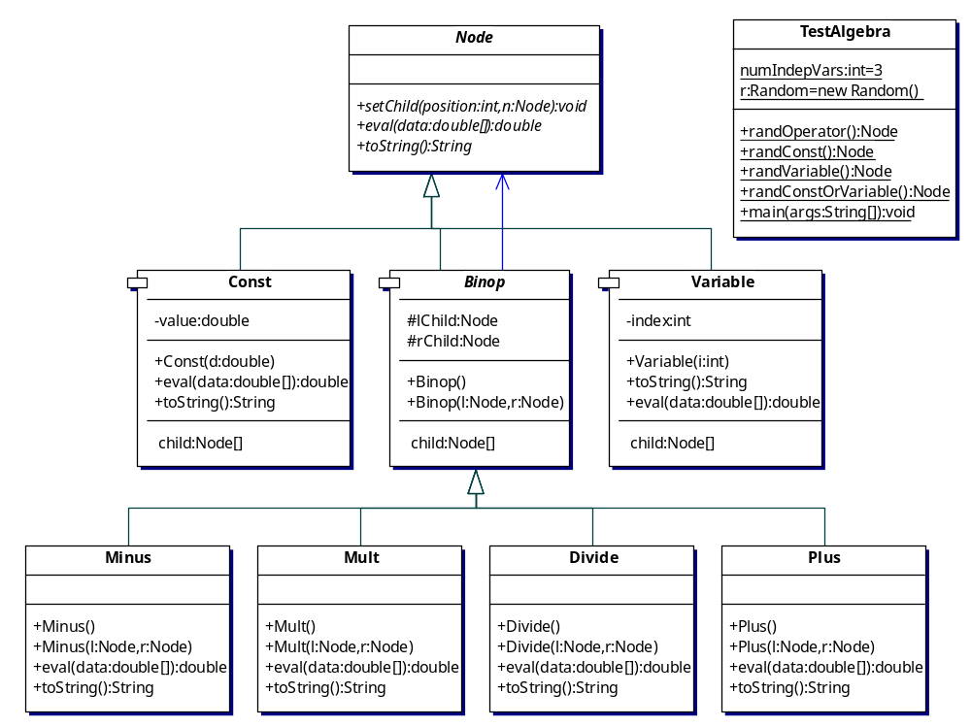

Note that Node should be an abstract class, for reasons that should become apparent later.

In this step, you will add the method addRandomKids(), first as an abstract method in Node, and then as a concrete method in Const, Binop, and Variable. addRandomKids() will have the responsibility of adding new child nodes to a tree, until a specified maximum tree depth is reached. addRandomKids() is easy for Const and Variable. It does nothing at all! This is because objects of these two types are terminal nodes; they can only appear at the “bottom” of a tree.

addRandomKids() for Binop is a little bit trickier. To generalize the code as much as possible (for future extensibility), you will create two new factory classes, OperatorFactory and TerminalFactory. Think of these as factories that can supply a Node object when asked. OperatorFactory will have a method getOperator() that supplies one of Plus, Minus, Mult, or Divide, at random. TerminalFactory will have a method getTerminal() that provides either a Const or a Variable, again at random.

The OperatorFactory needs to know the set of binary operators to choose from. So, its constructor will take as an argument a Node[] array that contains one of each of the four types of Binop. It then stores the array as a member variable. When OperatorFactory is asked (through its getOperator() method) to supply an operator, it will randomly choose one of the Binop nodes from its array and return a clone of this node. This implies that the top-level Node class will have to implement the Cloneable interface, as will be described in the lecture. (The code for Node’s clone() method is exactly the same as that shown for SimpleClass in the lecture notes.) This is why Node goes back to being an abstract class. Since all of our other classes derive from Node, they will be Cloneable also, with no additional work on our part.

TerminalFactory only needs to know the number of independent variables, so its constructor takes this number (call it numIndepVars) as an int argument, and stores it as a member variable. The getTerminal() method chooses a random number between 0 and numIndepVars. If this random number is less than numIndepVars, a Variable node is created whose index is the random number. Thus the index held by a Variable object will lie between 0 and numIndepVars-1. If the random number equals numIndepVars, a Const node is returned (with its value a random double in [0, 1}.

Now for the Binop method addRandomKids(). This method needs to be supplied with (i.e., has as arguments) an OperatorFactory object, a TerminalFactory object, an int specifying the maximum tree depth, and a Random object (a single Random object will be created for the entire program, and passed around as necessary). To ensure that the trees created don’t get too large, each and every Node will now hold an int (call it depth) that records how far down in the tree it is. When a Node object is first created (i.e., by its constructor), it has depth zero. When a Node is added to a tree, its depth variable is set to be one larger than that of its parent.

When the addRandomKids() method is called for a Binop node n, it works like this:
- If n’s depth is equal to maxDepth, the tree shouldn’t be enlarged any further. Set both its left and right children to be terminals (i.e., call getTerminal() for both, and set the depth of these new terminals to n’s depth plus 1.
- Otherwise, the tree continues to grow. First add a left child, by choosing a random number between 0 and (numOperators + numIndepVars).
- If this number is less than numOperators, add a new operator as the left child (by calling getOperator()). Set the new child’s depth to one larger than n’s depth. Then call the new child’s addRandomKids() method. This is the recursive step that keeps the tree building process going. The recursion stops when a terminal is created, since the addRandomKids() for terminal types returns immediately, having done nothing at all.
- Otherwise, add a terminal as the left child (by calling getTerminal()) Again, set the new child’s depth appropriately..
- Repeat this process for the right child.

In summary, here are the classes and methods you need to produce:

public class OperatorFactory {
private Node[] currentOps;
OperatorFactory(Node[] n) {//add }
public Node getOperator(Random rand) {// add}
public int getNumOps() {// add }
}

public class TerminalFactory {
private int numIndepVars;
TerminalFactory(int n) {// add }
public Node getTerminal(Random rand) {// add}
public int getNumIndepVars() {// add}
}

In Node:
public Object clone() {// add}
public abstract void addRandomKids(OperatorFactory o,
TerminalFactory t, intmaxDepth, Random rand);

In Binop:
public void addRandomKids(OperatorFactory o,
TerminalFactory t, int maxDepth, Random rand) {// add}

In Const and Variable:
public void addRandomKids(OperatorFactory o,
TerminalFactory t, int maxDepth, Random rand) {}

Here is my class TestAlgebra:
import java.util.*;

public class TestAlgebra {
static int numIndepVars = 3;
static int maxDepth = 5;
static Random rand = new Random();
public static void main(String[] args) {
double[] data = new double[3];
data[0] = 3.14;
data[1] = 2.78;
data[2] = 1.0;
Node[] ops = {new Plus(), new Minus(), new Mult(), new Divide()};
OperatorFactory o = new OperatorFactory(ops);
TerminalFactory t = new TerminalFactory(numIndepVars);
Node root = o.getOperator(rand);
root.addRandomKids(o, t, maxDepth, rand);
String s = root.toString();
System.out.println(s + " = " + root.eval(data));

}
}
This produces, on two successive runs:
(X0 - ((X0 + X2) - ((((X2 - X1) / X2) + ((0.6643226248148392 - X2) * (X0 / X1))) * ((X0 / X1) / ((X1 * 0.35270021072871505) - (0.8091377155646736 / X1)))))) = -4.537237792628336

((((X0 + (0.3210808107861137 - X2)) * (0.36531662741100246 + X2)) * X2) + (0.4765980340813758 - ((X1 - (X2 * X2)) + 0.75953773359674))) * (((((0.8395647772434062 - 0.7621193511598635) + 0.3617947763651407) / 0.3067093770466125) + X2) + X2)) = 4.452178301700404

(You might consider making these doubles print out with fewer digits after the decimal point. I should too!)

One big tip: Make sure you’ve imported java.util.* everywhere, so that the Random class is known.

Submit to Bb in the usual way.

